Client Details

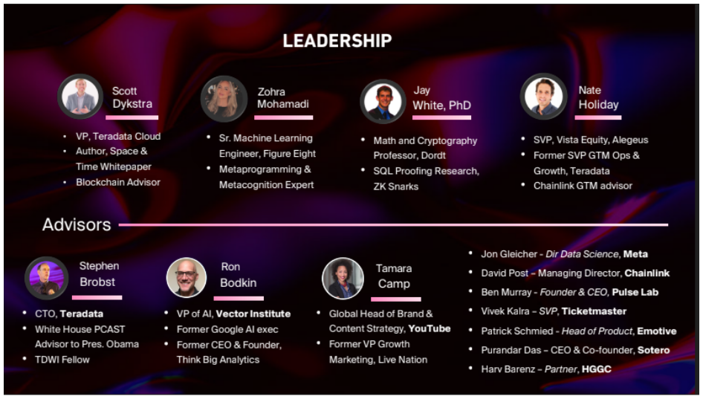

**First decentralized analytics platform to power a Trustless Web**

Team is working to build a web3-native, decentralized analytics platform. Dapp built on top of Space and Time will not only be block chain interoperability but will offer a tamper proof analytics infrastructure and be fully decentralized, transactional and analytical to deliver unmatched performance at scale.

**Promotional Website:**

<https://www.spaceandtime.io/>

Internal Team

Dapp frontend - [RACI](https://docs.google.com/spreadsheets/d/1KPsZSqXk_yIDSij--xBUpmNvJYihDUoP/edit#gid=1010994840)

Blockchain indexing - [RACI](https://docs.google.com/spreadsheets/d/1snJ_IjQxSvz_IZniDC02htgBppKkNHaW/edit?usp=sharing&ouid=103627645235882858264&rtpof=true&sd=true)

Data ingestion (Streaming) - [RACI](https://docs.google.com/spreadsheets/d/1Q16h7u1Yx_7NzgMrNoBCMKc1Y3C1SxTl/edit?usp=sharing&ouid=103627645235882858264&rtpof=true&sd=true)

DevOps - [RACI](https://docs.google.com/spreadsheets/d/1MIcDLSm-zpKDNFh5GaPpSajF_YrqwgnP/edit?usp=sharing&ouid=103627645235882858264&rtpof=true&sd=true-oQ4T8Qx-8n7PXd70GEdkg/edit#gid=0)

Dapp backend (Routing) - [RACI](https://docs.google.com/spreadsheets/d/1mKSRJL-IwC6FvIv7xQIz4NYh0d50BYxz/edit?usp=sharing&ouid=103627645235882858264&rtpof=true&sd=true)

NFT Community  
Diving Board

**Prerequisite**

Basics of Block Chain

Explore what Block Chain is and how it works?  
What is Etherium?  
Terms like Ether, Wei, Transaction, Gas, Block, Account, Mining, and Consensus   
what is Etherium 2.0?  
What is Dapp?  
What is Defi?  
What is Dao?

**Videos for understanding:**

[How does a Block Chain work- Simply Explained](https://www.youtube.com/watch?v=SSo_EIwHSd4)

[All about Block Chain| Simply Explained](https://www.youtube.com/watch?v=YJyXfjbBmc8)

[What is Etherium? A Beginner’s explanation in plain English](https://www.youtube.com/watch?v=jxLkbJozKbY)

[What is Crypto Currency Mining| Explained for beginners?](https://www.youtube.com/watch?v=2VtH-XAOjXw)

[12 Consensus Mechanism + how they work (Pros/Cons)](https://www.youtube.com/watch?v=3QCykHU89To)

[Proof of stack (vs. proof of work)](https://www.youtube.com/watch?v=M3EFi_POhps)

[Etherium 2.0 is coming in 2022 | what you must know!](https://www.youtube.com/watch?v=JSDuy7v73wI)

[What are Dapps? (12 decentralized application examples)](https://www.youtube.com/watch?v=oPIupbsVimc)

[What is DEFI? | What is decentralized finance? (Easy Explanation)](https://www.youtube.com/watch?v=S3-11Yyq1eg)

[What is DAO in Crypto? (Decentralized Autonomous Organization)](https://www.youtube.com/watch?v=KHm0uUPqmVE)

[28+ important Block Chain term explained | Block Chain terminology](https://www.youtube.com/watch?v=-VwTgmaNa2g)

**Terminology:**

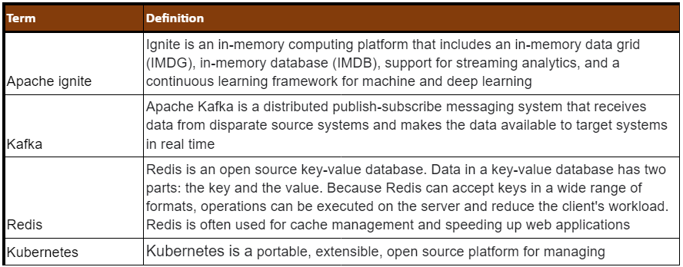 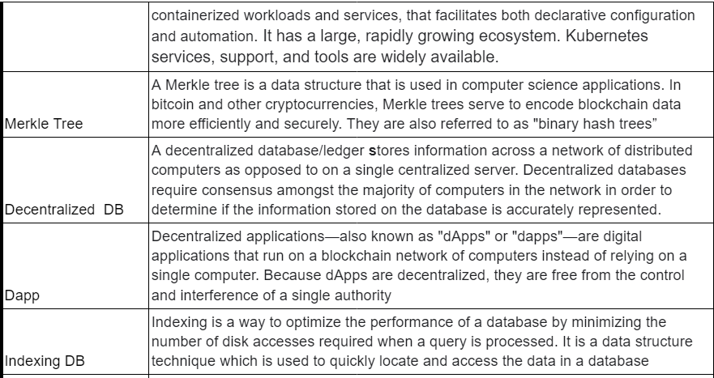

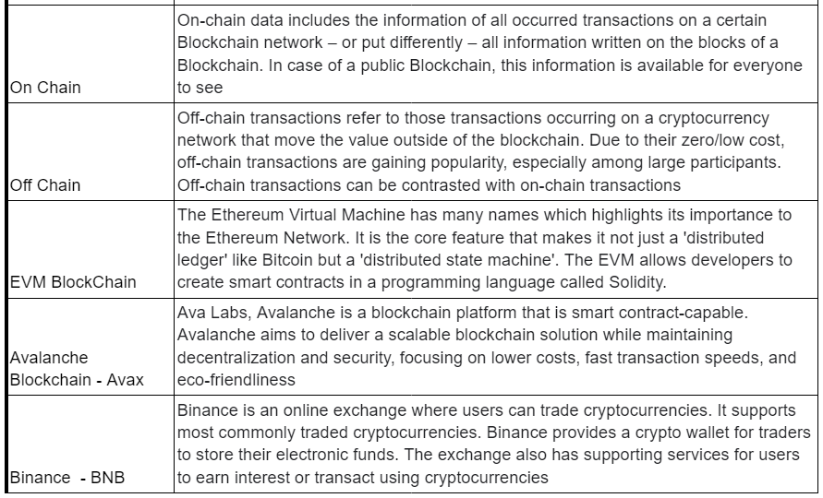

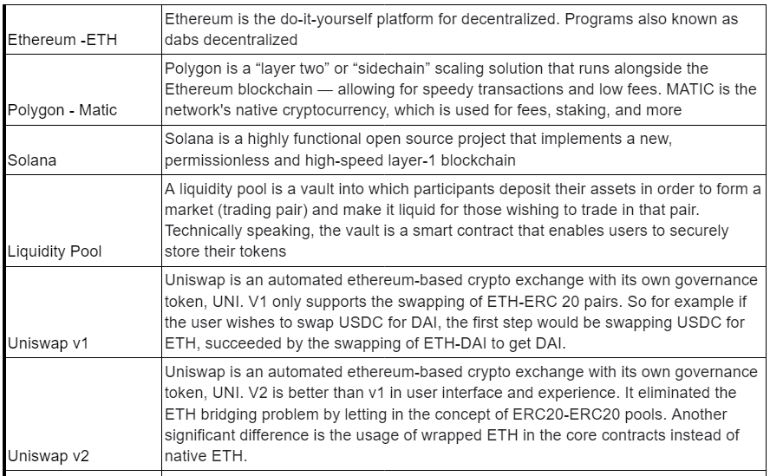 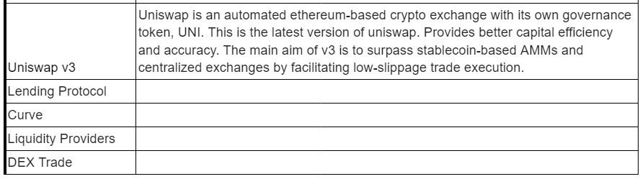

**Logical Architecture:**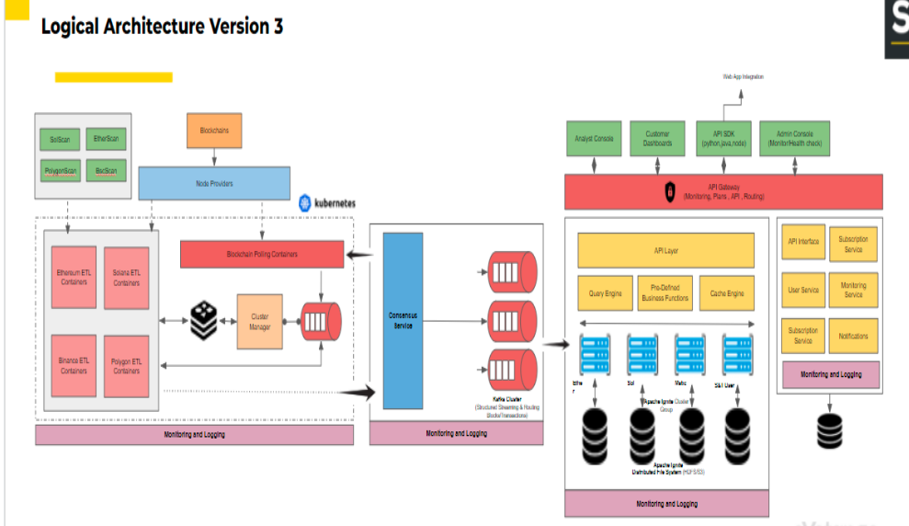

**Development Environment URL**

<https://space-time-demo.web.app/>

Other Links

[Dapp](https://drive.google.com/file/d/1wPQ5cP2iOlqAHt8ovDGioMAid6LUA_99/view?usp=sharing)  
[Dapp functional requirements with wireframes](https://drive.google.com/file/d/1ssb96uTxdwhaWlinj2AkyCxn8ZkeVVN5/view?usp=sharing)  
[Indexing & Ingestion](https://drive.google.com/file/d/1e_TWENhjr8VXYogGtGK7cbnYrpO_Vo66/view?usp=sharing)

Useful Documents and Links:

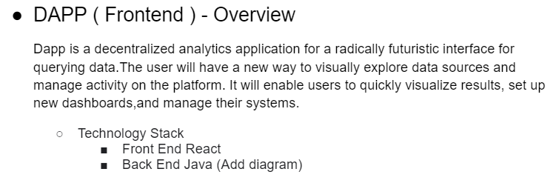 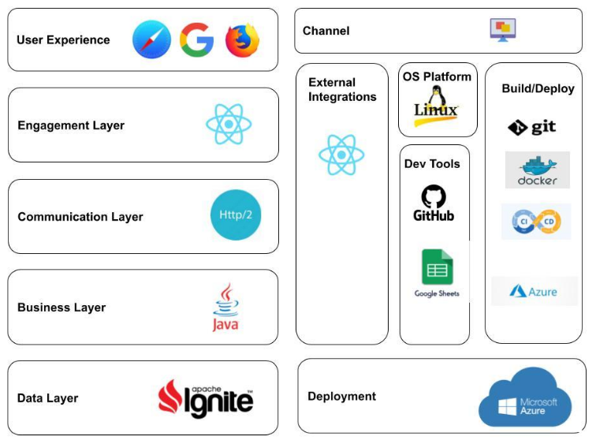 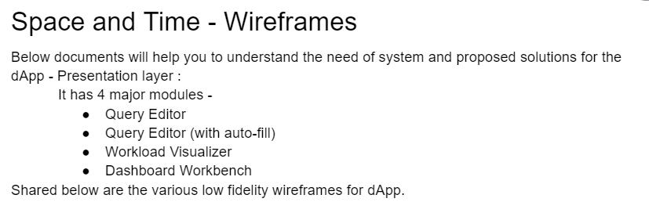 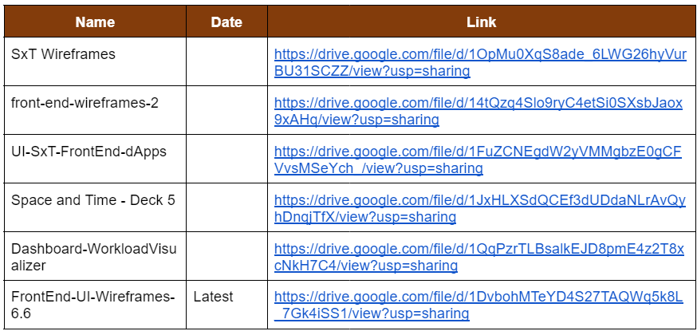

<https://drive.google.com/file/d/1OpMu0XqS8ade_6LWG26hyVurBU31SCZZ/view?usp=sharing>  
<https://drive.google.com/file/d/14tQzq4Slo9ryC4etSi0SXsbJaox9xAHq/view?usp=sharing>  
<https://drive.google.com/file/d/1FuZCNEgdW2yVMMgbzE0gCFVvsMSeYch_/view?usp=sharing>  
<https://drive.google.com/file/d/1JxHLXSdQCEf3dUDdaNLrAvQyhDnqjTfX/view?usp=sharing>  
<https://drive.google.com/file/d/1QqPzrTLBsalkEJD8pmE4z2T8xcNkH7C4/view?usp=sharing>  
<https://drive.google.com/file/d/1DvbohMTeYD4S27TAQWq5k8L_7Gk4iSS1/view?usp=sharing>

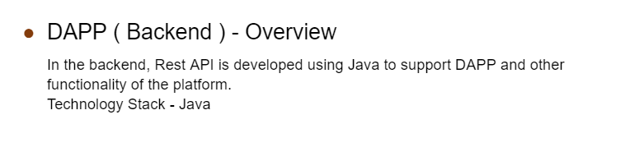 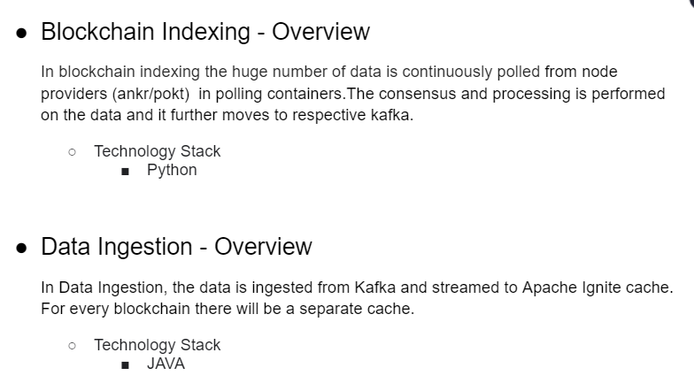

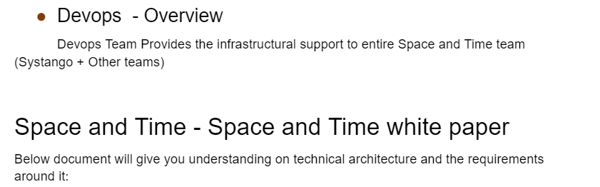  
[LINK](https://drive.google.com/file/d/1MFj_ChQwoWmm2yqbhT-KPMerYB3YHO8B/view?usp=sharing)

Useful Links:  
[Master Sheet](https://docs.google.com/spreadsheets/d/1LQhJWna-WA-tuHRmSxjW-tLX-EukrCnL/edit?usp=sharing&ouid=115748608354311161800&rtpof=true&sd=true)  
[All Credentials](https://docs.google.com/spreadsheets/d/1cJHte99HYTWQRUFFiNARBZqY3GdaL_iE/edit?usp=sharing&ouid=115748608354311161800&rtpof=true&sd=true)  
[Rulebook](https://docs.google.com/document/d/1_V9gCg6jTHK9WaNM5qSRdYS4S9OyaxLz/edit?usp=sharing&ouid=103627645235882858264&rtpof=true&sd=true)  
[On Boarding Video](https://drive.google.com/file/d/1kQrufI04HriWuvhOEw7M5mN7lr1Ma-lX/view?usp=sharing)

Similar Products

Bit query Explorer – Listing Block chain  
<https://www.blockchain.com/charts/n-transactions-per-block>

The graph –dashboard- Graph view  
<https://thegraph.com/en/>

Dune network- Query Editor  
<https://dune.com/browse/dashboards>

Superset- Query editor  
<http://www.superset.ai/>

Metabase- Query Editor  
<https://www.metabase.com/>

Big chain DB – database  
<https://www.bigchaindb.com/>